6 EASY Tips to 10x Any Site's Design

0:00
There are six very simple design techniques that you can use to make
0:03
websites that not only convert, but cause someone to stop and
0:07
go, Hey, that's actually awesome.
0:09
The best part is that you can do them right away on any website that you're
0:12
building without needing a ton of experience or a full degree in web design.
Tip 1
0:16
So let's start with the fastest win fixing typography.
0:19
You'll often hear people say.
0:21
Only use one font on a website.
0:25
Honestly, I've said that too.
0:27
It's not that it's bad advice, but that's just level one of typography.
0:32
For websites, there are two whole other levels.
0:35
Level two is using something called Super Families.
0:39
These are just massive fonts where you'll have one specific family that's
0:44
got San Serif rif, and even Monica.
0:47
Sometimes, and they're all built to gel seamlessly together.
0:52
Now, level one and level two are great options.
0:55
You're gonna see a lot of awesome websites using these very techniques,
0:59
but level three gives it that extra little push, and it's all about using.
1:04
Different font, families from different foundries that mesh together like
1:09
they were meant for each other.
1:11
We're talking about font combos and what actually makes combining
1:15
fonts a lot easier is starting with something called your anchor font.
1:20
Now, most people will tell you that you want to anchor all
1:23
of your font choices around.
1:25
Your body font.
1:26
I actually do the opposite.
1:28
I start with the headline first and then find everything else to support that guy.
1:34
So why do I start with the headlines first?
1:37
Well, on a website, the headline is the main text that you see, and I feel
1:42
like your anchor should kind of set the whole personality for the page.
1:46
Is it more modern?
1:49
Is it more technical?
1:50
Maybe it's warm and approachable, but no matter what, the anchor should
1:55
always match the brand of the business.
1:57
Once you've got that dialed in, it's it's time to find fonts that just
2:02
automatically support that anchor.
2:04
So every font that you add after that should feel like it at least came
2:08
from the same world, but hopefully it also adds some contrast to keep
2:12
things kind of visually interesting.
2:14
But here's where you want to be careful.
2:15
Don't pick fonts that are just way too similar, like Georgia and Times New Roman.
2:21
They're, they're so close, but at the same time very different.
2:25
So this feels unintentional.
2:27
What you're really going after is something that has enough contrast that
2:32
it can create some visual interest without making things confusing for the user.
2:37
A great resource that makes this way easier is a website called Fonts in Use.
2:42
You can go there and search for.
2:44
Any of your anchor fonts and see what other designers have used
2:47
to pair with that specific font.
2:50
So let's do this ourselves right now.
2:52
Let's take this website, which is not bad, but it's not super interesting
2:57
and just kind of spice it up.
2:59
So for our anchor font, I'm gonna go with one called Instrument rif.
3:04
Now, this is a free Google font, but it's also pretty cool.
3:08
And because it's super condensed, we can actually make it a lot bigger, which is
3:13
something that I love about headlines.
3:16
They really command attention when they've got more size.
3:18
So let's take our anchor, let's.
3:20
Take instrument serif, go over to fonts and use, and just type
3:25
that in and see what we get.
3:27
And already, we've got a handful of, of really great options over here.
3:31
These are all completely free.
3:33
Mona Sands, Anton.
3:34
Great solid fonts that we're not gonna have to pay for.
3:37
Some of these you would have to pay for, but I'm gonna stick with one that we're
3:41
not gonna have to spend a ton of money on so that it can be accessible to everyone.
3:45
So I'm really liking this.
3:46
Geist Sands and look how different it is in comparison to the width
3:53
of each character Instrument.
3:55
Sands is much more condensed and geist is much more spread out.
3:59
So this is gonna provide that contrast that we're looking for.
4:03
So let's take this geist font, go over to our Figma file and just change our
4:07
subheading to kind of see how it works.
4:09
Sometimes you just gotta test out a lot of different variations.
4:13
But this is looking pretty good.
4:15
There's, there's a lot of good contrast between our header and our subheading, but
4:20
it doesn't feel like they're coming from totally opposite ends of the spectrum.
4:24
So I think we're gonna dial this in with GE and just with that little
4:27
change, this is already starting to be a lot more visually appealing.
4:31
It still doesn't have anything that quite makes you stop scrolling.
4:35
That's the next tip.
Tip 2
4:36
You've probably heard a lot of people say that boring or.
4:39
Plane sites are way better for business, and you always wanna keep it simple.
4:44
And as a web designer, you're not trying to impress other designers or
4:49
win awards, and that's not bad advice.
4:53
But a website isn't just a checkout machine.
4:57
It's often the first and only meeting that people are gonna have
5:00
with you or your client's brand.
5:02
And if it doesn't make somebody feel something.
5:04
You're not gonna be remembered.
5:06
And when you start looking at websites for inspiration, you're gonna find
5:09
that every website that really captures your attention, there's something
5:13
that you notice almost right away.
5:15
Maybe it's a certain type of font, maybe it's an image or an object.
5:19
This is what I like to call the star.
5:22
Of the show, it's, it's one thing that makes people feel something and
5:25
it kind of anchors their attention long enough for them to actually
5:28
take the action that we want them to.
5:30
Like.
5:30
Look at this website here.
5:32
The first thing that you notice are these gradient elements with some text on top
5:38
of them and the really cool gradients.
5:40
They've been done really well.
5:41
The movement is neat, and then you can go back and forth and interact with it.
5:45
This is something.
5:46
That is definitely the star of the show.
5:48
It commands your attention and makes me actually care about what
5:51
the rest of the page is saying.
5:53
But here's where a lot of designers get lost.
5:56
Picking a star just because it looks cool, is where this goes.
6:00
Way south.
6:01
I am a big fan.
6:03
Of Brandon Sanderson.
6:04
Any Sander fans out there?
6:06
Nerds unite.
6:07
If you don't know who he is, he's a pretty prolific fantasy author and I, I
6:11
remember him talking about how a lot of the books that he writes start with what
6:16
he calls a seed dress of the emerald seed.
6:20
Is a perfect example of this.
6:22
His what if on this was, what if the princess bride got flipped and the
6:27
princess went out to save the prince?
6:31
So from that one question, he built this entire world.
6:35
Your star works the same way.
6:37
It's your seed.
6:38
You pick one thing that's connected to the overall story of the website, and
6:44
you let everything grow around that.
6:46
So for this site that we've been working on, this is a SaaS product,
6:51
and reading a little bit about it, this handles operations for service based.
6:56
Businesses.
6:57
The whole point of a product like this is, is taking a mess of complex data
7:02
and making it feel really simple through things like dashboards and, and charts.
7:06
So what if the star actually called back to that?
7:10
Like what if it visually referenced the the chart?
7:13
And the dashboards that the users are gonna associate with it.
7:17
Now, we're not just trying to put up a chart on here.
7:19
We, we want it to feel a little bit more abstract, so, so let's go to Unsplash and
7:23
see if we can find something that fits.
7:26
I'm just gonna type in orange gradient to kind of fit with our button, and
7:30
then vertical lines to match the chart idea that we're looking for.
7:34
So right off the bat, this image right here is pretty cool.
7:36
It's, it looks like a graph kind of abstractly, but it's
7:41
also really visually stunning.
7:42
So let's take our image.
7:43
Drop it onto our website and we'll just kind of center it up and bring
7:47
it underneath all of our elements.
7:49
And because we don't want all this color to compete with our text, let's go ahead
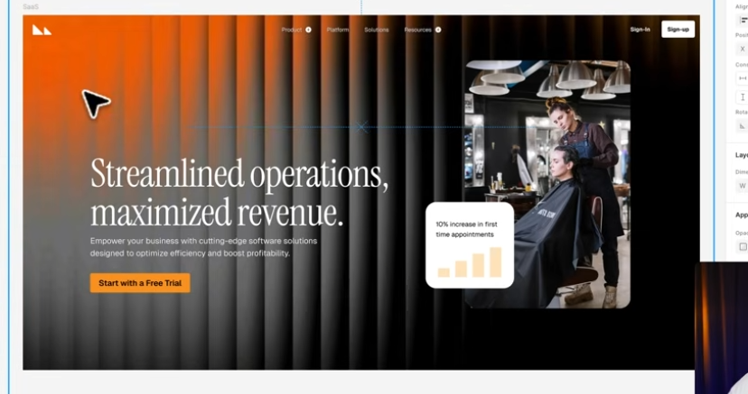
7:53
and flip this horizontally and then we'll just add a little shape underneath
7:59
it and mask it out to where it's, it's still subtle, but making an impact.
8:04
Let's adjust this just a little bit and then I think we should be good to go.
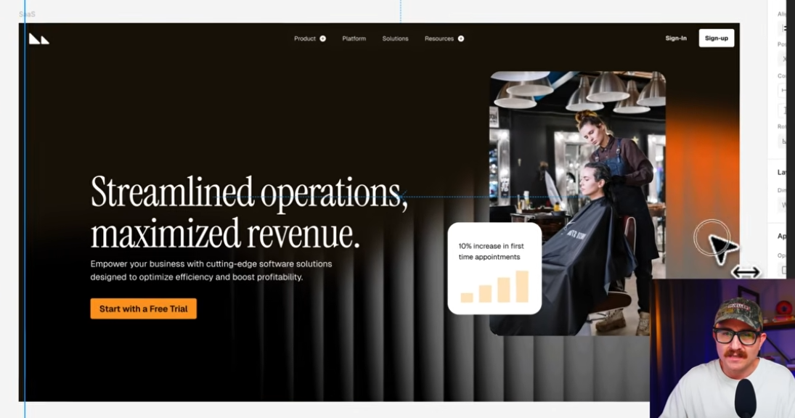
8:10
And already look at where we've come from.
8:13
We've just done two things, and this is looking much better, but there's
8:17
another technique that we can use to kind of tie everything together.
Tip 3
8:21
Adding little design choices or even little design elements that
8:24
kind of consistently show up in different ways across your website
8:28
makes the whole thing feel much more cohesive, and it can actually
8:32
strengthen the user experience as well.
8:34
This is where something called visual rhyming comes in.
8:37
Visual rhyming is where.
8:38
You repeat little details across the site so that everything feels like
8:42
it's kind of from the same universe.
8:45
Like, look at this website here.
8:47
They took these curved shapes from their logo, put them in these overlays on
8:52
their buttons, and even in this arrow.
8:55
Next to this link.
8:56
This is a lot of cool visual rhyming, but it doesn't just have to be shapes.
9:01
It could be colors like a, a, a bunch of different gradients that
9:05
kind of all show up in different ways, maybe even different textures.
9:08
It doesn't necessarily mean that you're just repeating visual elements.
9:12
It's more like you're taking components of a really strong visual
9:16
element, like the star of the show, and using them throughout the whole
9:20
site on other different elements.
9:23
Check out this website.
9:24
Right here.
9:25
They clearly have made the star of the show.
9:28
This key element right here, which is really cool because it's all
9:32
about unlocking your rental business, but as you scroll down, you kind
9:37
of see different elements from that key show up in different ways.
9:40
Like look at all of these.
9:42
Text cards that are showing up around this.
9:44
Even the background of this element, this, they have done just such a
9:49
great job on this visual rhyming.
9:53
This is the kind of website that makes you simultaneously inspired and
9:56
want to quit all at the same time.
9:59
So it's really good.
10:00
Good job to whoever did this on our side, I think we can do something
10:04
with these triangles in the logo.
10:07
First, let's take these plus icons and trade 'em out.
10:11
With a good old dropdown icon, which is already feeling a lot more cohesive.
10:18
Then let's add almost like an arrow in our main call to action, and then something
10:25
that I think is gonna make an even bigger impact is changing out these rectangles.
10:30
Our triangles using the triangles, a mask over our image, and then
10:34
the triangle for the call out box.
10:36
And because we've got this chart motif, I don't think we need the chart in
10:40
this little card right here anymore.
10:42
Cool.
10:42
We've got a whole lot of rhyming going on now, but even with all of that.
Tip 4
10:47
A lot of websites are standing out because you kind of feel like
10:51
you're walking into them rather than just scrolling up and down.
10:54
So in order for users not to check out on our website, because everything just
10:58
kind of seems business as usual, we need to make the site feel a bit more
11:02
tangible like, like it kind of exists.
11:04
In the real world, and a really simple way to do that is using
11:07
what I like to call depth.
11:09
Depth is something that kind of bridges the gap between the
11:13
tangible and the online world.
11:16
So think things like textures on the main background or maybe 3D element.
11:20
Set.
11:20
You feel like you can almost touch them on the site instead
11:23
of just scrolling through it.
11:24
But here's the key In all of this, all of these textures, all of
11:28
this depth needs to be settled.
11:31
We don't wanna compete with the star of the show.
11:33
So think of it like real world details that are just kind of there.
11:37
You, you notice them, but they're not asking for your attention.
11:40
So let's go ahead and do that with the example that we've been.
11:43
Working on.
11:43
First, let's add some texture to the star of the show.
11:47
We'll just add a little bit of noise to it.
11:49
There's this really cool plugin called Noise and Texture that allows you to
11:52
do that straight within Figma rather than having to open up Photoshop.
11:56
There's just a few settings you gotta select and then bam, you're good to go.
12:00
Then I think there's an opportunity to kind of rhyme with the glass feel of the
12:05
star of the show, and then add a little bit more depth to it by taking these.
12:10
Cards and some of the elements on our navigation and just adding some
12:16
glass effect, and now it's definitely starting to feel like just more than
12:20
code and pixels on the floating page.
Tip 5
12:23
Our next step is actually even more subtle, if you can believe it, but
12:26
it can make a pretty big difference.
12:27
Early on in my web design journey, I got really into reading other
12:30
businesses, design systems.
12:32
Kind of nerdy.
12:33
I know, but helpful.
12:35
And when I was reading Google's material design, I noticed something.
12:38
They don't just use 100% opacity on all of their text.
12:41
They literally spell out 87% opacity for text.
12:45
That's high emphasis or the important stuff.
12:48
And then 60% for the medium emphasis.
12:51
There's a little bit of debate about why they do this, but regardless
12:55
of where you land, using opacity is a massive win for hierarchy.
13:00
Your eye immediately knows what to read first, what you can skim
13:03
through, and then maybe what to ignore unless you really need it,
13:06
and you can steal that exact idea on.
13:09
Your own website.
13:10
Now let's keep this headline at a hundred percent opacity.
13:13
This is actually what we want people to pay attention to the most
13:17
when they first visit our website.
13:19
But we can take this subheading and drop that puppy all the way
13:23
down to 70%, and here's a little bit of the before and after.
13:28
The one on top, a hundred percent opacity on all the texts, one on the bottom.
13:32
Has a few levels.
13:33
Like I mentioned before, it's pretty subtle, but man, it really
13:37
makes this page feel intentional.
Tip 6
13:39
This final tip is one that most web designers aren't gonna do, but it's gonna
13:43
make a huge difference in the outcome of the websites that you're working on.
13:47
I got this idea from a concept that I learned when I was doing music for
13:52
a living and I was producing people's albums, and I learned that the.
13:55
Best producers will hear an artist's song and then have them speed it up a
14:00
lot and then slow it way down a lot.
14:02
Maybe sing the octave up or sing the octave down, maybe change the keys.
14:07
Doing that forces the musicians out of their original thought
14:10
so that they can finally find something that is the absolute.
14:14
Best version of the song, but you can't do that if you're just taking
14:18
the first version and then trying to adjust it until it's better and better.
14:22
You gotta just do something completely different.
14:25
And the same is true with web design.
14:28
Take your first thought and then try something Totally.
14:31
Different.
14:31
Maybe make a light mode, maybe change the layout, try a different star of the show.
14:38
This one example that I showed you throughout the video had 12
14:43
different versions of the same star.
14:46
The, the first version would've probably been fine, but if I hadn't kept.
14:50
Going, it wouldn't have been nearly as good.
14:52
So play around, have fun with your ideas until that angel gets carved out of
14:57
the rock like Michelangelo used to say.
Wrap Up and Next Video
14:59
These tips can instantly level up almost any website that you're working
15:03
on, but there's still just that.
15:07
Tips.
15:07
If you wanna become the kind of designer who can walk into absolutely
15:11
any project and know exactly what to do, you have to move past tips
15:15
and build the underlying skills.
15:18
That's why I made this video the only five web design skills that actually matter.
15:24
Check that out next, and go design something great.
15:26
Don't forget, if you don't quit, you win.

